Table : adminn

create table adminn (

adminn_id number(30),

name varchar(30) not null,

email varchar(30) not null,

mobile number(11) not null,

join_date date not null,

nid number(13) not null,

password varchar(20) not null,

primary key (adminn_id));

CREATE SEQUENCE adminn_id

START WITH 1

INCREMENT BY 1

insert into adminn values (adminn_id.nextval,'anik','anik@gmail.com', 01712366151,sysdate,3231433123,'adsasd')

insert into adminn values (adminn_id.nextval,'miraz','miraz@gmail.com', 0173423522,sysdate,1231241423,'sffagas')

Table : tourist_info

create table tourist_info(

t_id number(20) not null,

name VARCHAR(50) not null,

email varchar(20) not null,

age number(30) not null,

gender varchar(20),

nid number(20) not null,

password varchar(8) not null,

primary key (t_id));

CREATE SEQUENCE t_id

START WITH 1

INCREMENT BY 1

insert into tourist_info values (t_id.nextval,'sohan','sohan@gmail.com', 22,'male', 123456789123, 54642)

insert into tourist_info values (t_id.nextval,'tamim','tamim@gmail.com', 32,'male', 412313412312, 13512)

insert into tourist_info values (t_id.nextval,'afif','afif@gmail.com', 22,'male', 414135123412, 24534)

insert into tourist_info values (t_id.nextval,'soumya','soumya@gmail.com', 27,'male', 345678912323, 73453)

insert into tourist_info values (t_id.nextval,'sakib','sakib@gmail.com', 34,'male', 623523643322, 73445)

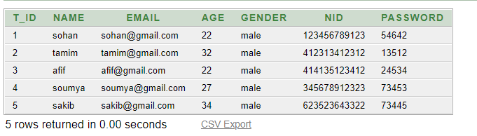

Table : emp

create table emp(

e_id number(20) not null,

name VARCHAR(50) not null,

email varchar(20) not null,

age number(30) not null,

gender varchar(20),

nid number(20) not null,

password varchar(8) not null,

joindate date not null,

primary key (e_id));

CREATE SEQUENCE e_id

START WITH 1

INCREMENT BY 1

insert into emp values (e_id.nextval,'razi','razi@gmail.com', 22,'male', 123456789123, 54642,sysdate)

insert into emp values (e_id.nextval,'sadi','sadi@gmail.com', 32,'male', 412313412312, 13512,'20-AUG-22')

insert into emp values (e_id.nextval,'maruf','maruf@gmail.com', 22,'male', 414135123412, 24534,'18-AUG-22')

insert into emp values (e_id.nextval,'hridoy','hridoy@gmail.com', 27,'male', 345678912323, 73453,'15-AUG-22')

insert into emp values (e_id.nextval,'siyam','siyam@gmail.com', 34,'male', 623523643322, 73445,'12-AUG-22') 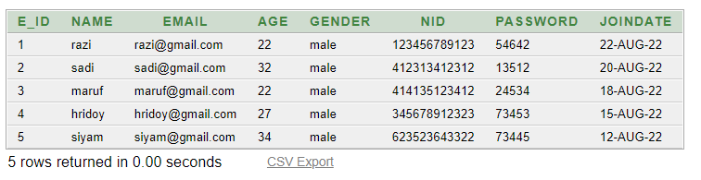

Table : Salgrade

create table salgrade(

grade number(20) not null,

salary number(20) not null,

primary key (grade)

);

insert into salgrade values (1,40000)

insert into salgrade values (2,30000)

insert into salgrade values (3,25000)

insert into salgrade values (4,20000)

insert into salgrade values (5,18000)

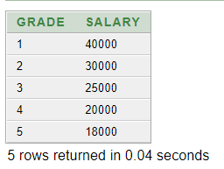

Table : sal_detail

create table sal_detail(

e_id number(20) not null,

grade number(20) not null,

FOREIGN KEY (grade) REFERENCES salgrade(grade),

FOREIGN KEY (e_id) REFERENCES emp(e_id)

);

insert into sal_detail values (1,1)

insert into sal_detail values (2,3)

insert into sal_detail values (3,2)

insert into sal_detail values (4,5)

insert into sal_detail values (5,4)

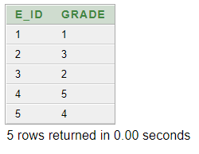

Table : payment

create table payment(

pay_id number(20) not null,

quantity number(20) not null,

pay_type varchar(20) not null,

pay_amount number(20) not null,

t_id number(20) not null,

primary key (pay_id),

FOREIGN KEY (t_id) REFERENCES tourist(t_id)

);

CREATE SEQUENCE pay_id

START WITH 1

INCREMENT BY 1

insert into payment values (pay_id.nextval,3,'cash',1000,4)

insert into payment values (pay_id.nextval,1,'bkash',800,3)

insert into payment values (pay_id.nextval,1,'cash',1500,2)

insert into payment values (pay_id.nextval,3,'cash',1100,5)

insert into payment values (pay_id.nextval,2,'bkash',1400,1)

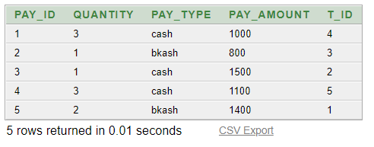

Table : booking

create table booking(

book_id number(20) not null,

book_type VARCHAR(20) not null,

pay_id number(20) not null,

primary key (book_id),

FOREIGN KEY (pay_id) REFERENCES payment(pay_id)

);

CREATE SEQUENCE book_id

START WITH 1

INCREMENT BY 1

insert into booking values (book_id.nextval,'CCA', 4)

insert into booking values (book_id.nextval,'DSA', 5)

insert into booking values (book_id.nextval,'CFD', 1)

insert into booking values (book_id.nextval,'CCA', 3)

insert into booking values (book_id.nextval,'DSA', 2)

